Feedback

I spent about a total of 20 hours completing my final website.

The easiest part of the project was making the about us page.

The most difficult and tedious was having a navigation bar and navigation tabs with all correct links.

The first feedback that was incorporated into my website was the suggestion that I should only have one form of navigation for users to navigate the site. In my original idea for the site, I wanted to include a hamburger menu and a more descriptive navigation bar. However, it was brought to my attention that this could be confusing for some users when coming to the site for the first time. I thought it would be better to just go with the navigation bar at the top of each page and I decided to leave out the hamburger menu to make sure that I was not confusing users. I included my prototype image with the circled problem areas that was suggested to me and an image of what I decided to incorporate into my final webpage. 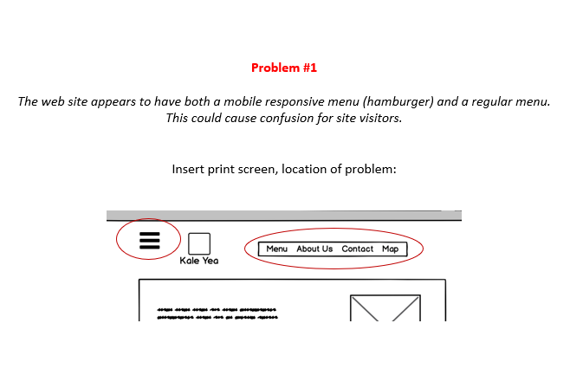

The next feedback that I decided to incorporate into my website was that instead of adding a menu button to the items that are listed under the featured menu items I decided to leave the button out completely. It was brought to my attention that this button was just added distraction and it was not necessary for the website’s functionality. I have included my prototype image with the circled problem and an image of what my website now looks like.

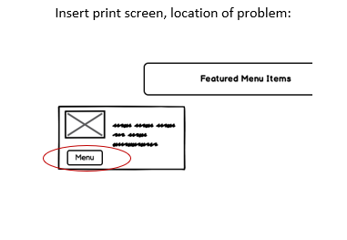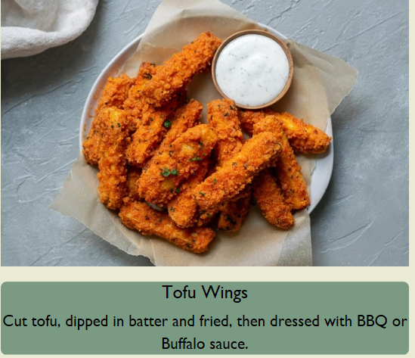

The next feedback that I decided to incorporate into my website was to give a brief description of the restaurant on the main page, and include what type of restaurant it is, dine-in or take-out. The last piece of feedback that I decided to incorporate into my website was keeping the navigation bar on each page of the website in a consistent area. In my prototype, I had planned out that I was going to move the main navigation bar to the bottom of the menu page to make room for the sub-navigation bar of the different types of food. However, I understand that this could be confusing for users when a navigation bar is consistently in on place on every page and in a different place on one separate page. I have included an image of my prototype which shows where I had planned on putting my navigation bar in the menu page, which would have been different from the rest of the pages. I have also included my actual website navigation bar on the menu page to illustrate what I did for the project.

